Date: 
HISTORY FORM FOR PATIENT WITH TEMPOROMANDIBULAR DISORDER

Patient’s Name:
Date of Birth: Age: Sex: Male Female
S.S.N./S.I.N.:
Address:
City: State/Province Zip/Postal Code:
Referred by:

MAJOR REASON FOR CURRENT EVALUATION:
1) Describe what you think the problem is:
2) What do you think caused this problem?
- Describe, in order (first to last), what you expect from your treatment:

GENERAL HISTORY:
1) Are you presently under the care of a physician or have you been in the past year? YES NO
Physician’s name: Condition treated:
Treatment:
Name of medication(s) you are currently taking:
Poor Average Excellent
2) How would you describe your overall physical health? 0 1 2 3 4 5 6 7 8 9 10
3) How would you describe your dental health? 0 1 2 3 4 5 6 7 8 9 10
Dentist’s name: Date of last appointment:
4) Have you had any major dental treatment in the last two years? YES NO
If yes, please mark procedure(s) Orthodontics Periodontics Oral Surgery Restorative
Date(s) of Third Molar (wisdom tooth) extraction(s):

FACIAL INJURY/TRAUMA HISTORY:
1) Is there any childhood history of falls, accidents or injury to the face or head? YES NO
Describe:
2) Is there any recent history of trauma to the head or face? (Auto accident, sports injury, facial impact) YES NO
Describe:
3) Is there any activity which holds the head or jaw in an imbalanced position? (Phone, swimming, instrument) YES NO
Describe:

TMD TREATMENT HISTORY:
1) Have you ever been examined for a TMD problem before? YES NO
If yes, by whom? When?
2) What was the nature of the problem? (Pain, noise, limitation of movement)
3) What was the duration of the problem? Months Years Is this a new problem? YES NO
4) Is the problem getting better, worse or staying the same?
5) Have you ever had physical therapy for TMD? YES NO
If yes, by whom? When?
6) Have you ever received treatment for jaw problems? YES NO
If yes, by whom? When?
What was the treatment? (Please mark below)
Bite Splint Medication Physical Therapy Occlusal Adjustment Orthodontics Counseling Surgery
Other (Please explain)

CURRENT MEDICATIONS/APPLIANCES:
No Pain Moderate Pain Severe Pain
1) Degree of current TMD pain: 0 1 2 3 4 5 6 7 8 9 10
2) Frequency of TMD pain: Daily Weekly Monthly Semi-Annually
Is there a pattern related to pain occurrence? Upon Waking Morning Afternoon Evening After Eating
3) Are you taking medication for the TMD problem? YES NO If so, what type?
How long? Who prescribed the medication?
4) Are the medications that you take effective? YES NO Conditional
5) Are you aware of anything that makes your pain worse? YES NO If yes, what?
6) Does your jaw make noise? YES NO
RIGHT Clicking Popping Grinding Other:
LEFT Clicking Popping Grinding Other:
7) Does your jaw lock open? YES NO When did this first occur?: How often?
8) Has your jaw ever locked closed or partly closed? YES NO
When did this first occur? How often?
9) Have any dental appliances been prescribed? YES NO
If yes, by whom? When?
Describe:
10) Are these appliances effective? YES NO
11) Is there any additional information that can help us in this area?

CURRENT STRESS FACTORS: (Please mark each factor that applies to you)
Death of Spouse | Major Illness or Injury | Major Health Change in Family
Business Adjustment | Divorce | Pending Marriage
Financial Problems | Pregnancy | Career Change
Fired from Work | Marital Reconciliation | Taking on Debt
Death of Family Member | New Person Joins Family | Other
Marital Separation

HABIT HISTORY: (Please mark your answer to each question)
1) Do you clench your teeth together under stress? YES NO DON’T KNOW
2) Do you grind/clench your teeth at night? YES NO DON’T KNOW
3) Do you sleep with an unusual head position? YES NO DON’T KNOW
4) Are you aware of any habits or activities that may aggravate this condition? YES NO DON’T KNOW
Describe:

SYMPTOMS: (Please mark each symptom that applies)
A. HEAD PAIN, HEADACHES, FACIAL | D. TEETH AND GUM PROBLEMS | H. THROAT PROBLEMS
PAIN | Clenching, Grinding at Night | Swallowing Difficulties
Forehead L R | Looseness and/or Soreness of Back | Tightness of Throat
Temples L R | Teeth | Sore Throat
Migraine Type Headaches | Tooth Pain | Voice Fluctuations
Cluster Headaches |  | Laryngitis
Maxillary Sinus Headaches (under the eyes) | E. JAW AND JAW JOINT (TMD) | Frequent Coughing/Clearing Throat
Occipital Headaches (back of the head with or | PROBLEMS | Feeling of Foreign Object in Throat
without shooting pain) | Clicking, Popping Jaw Joints | Tongue Pain
Hair and/or Scalp Painful to Touch | Grating Sounds | Salivation
 | Jaw Locking Opened or Closed | Pain in the Hard Palate
B. EYE PAIN OR EAR ORBITAL | Pain in Cheek Muscles
PROBLEMS | Uncontrollable Jaw/Tongue | I. NECK AND SHOULDER PAIN
Eye Pain – Above, Below or Behind | Movements | Reduced Mobility and Range of
Bloodshot Eyes |  | Motion
Blurring of Vision | F. PAIN, EAR PROBLEMS, | Stiffness
Bulging Appearance | POSTURAL IMBALANCES | Neck Pain
Pressure Behind the Eyes | Hissing, Buzzing, Ringing or | Tired, Sore Neck Muscles
Light Sensitivity | Roaring Sounds | Back Pain, Upper and Lower
Watering of the Eyes | Ear Pain without Infection | Shoulder Aches
Drooping of the Eyelids | Clogged, Stuffy, Itchy Ears | Arm and Finger Tingling, Numbness,
 | Balance Problems – “Vertigo” | Pain
C. MOUTH, FACE, CHEEK AND CHIN | Diminished Hearing
PROBLEMS
Discomfort | G. OTHER PAIN
Limited Opening | If so, please describe:
Inability to Open Smoothly | If so, please describe:
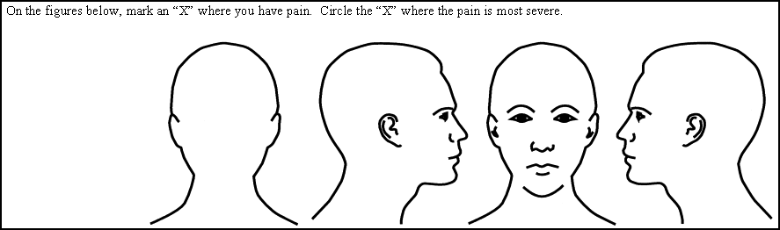
© American Association of Orthodontists 1999

